**NeedARide- A Ride Share Application**

**Abstract**

Public transportation is less frequent in Warrensburg area. Initiatives like Night Ryder, although helpful, are only for local commute, and are available only for small time periods. International Students in UCM depend mostly on the College Shuttles for their transportation to Lee Summit campus. Uber rides are scarce in the Warrensburg area. New Age taxi services like ETS Taxi are too expensive for students to afford. For travelling less frequented destinations, like Airport or SSN office or even downtown, students are dependent on rides from friends.

Now Students get their rides - by posting on Facebook, international mailing list or through some WhatsApp groups. NeedARide portal is a solution for this problem. It will serve as a centralized platform which will connect the entire student community of UCM.

NeedARide is a ride sharing app which serves as a common platform connecting the drivers and riders.

**Introduction**

Urban transportation needs are usually focused more on public transportation. But Carpooling and ride sharing provides a better alternative, as it ensures the full utilization of resources which are already in use. People travelling in the same route can share their rides and save on money, gas, reduce the congestion on roads, and leave a smaller carbon foot print. As per statistics 9% of Missourians carpooled to work. Carpooling among students can prove to be efficient and affordable as there will be usually a good number of students travelling in the same route.

Carpooling is popular among international students who are yet to get their driving permit, or don’t own a car. New Student drivers prefer to have a company when they drive in unfamiliar roads or may just want to split the gas fares. Now students depend on postings on Facebook group, International mailing list or a few localized WhatsApp groups for getting rides. Some of them end up not getting the rides they need because these methods are not effective. Posts in Facebook and mailing lists get lost among hundreds of other posts. WhatsApp group is localized to a few number of students, it does not ensure that your request actually reaches a driver or a person who needs a ride.

**Advantages**

* Students can use NeedARide and get rides without having to login or registering in another portal
* Rides are offered for and by students.
* Can be monetized or provided free.
* The App provides a way for connecting Drivers and riders.

**Application Architecture**

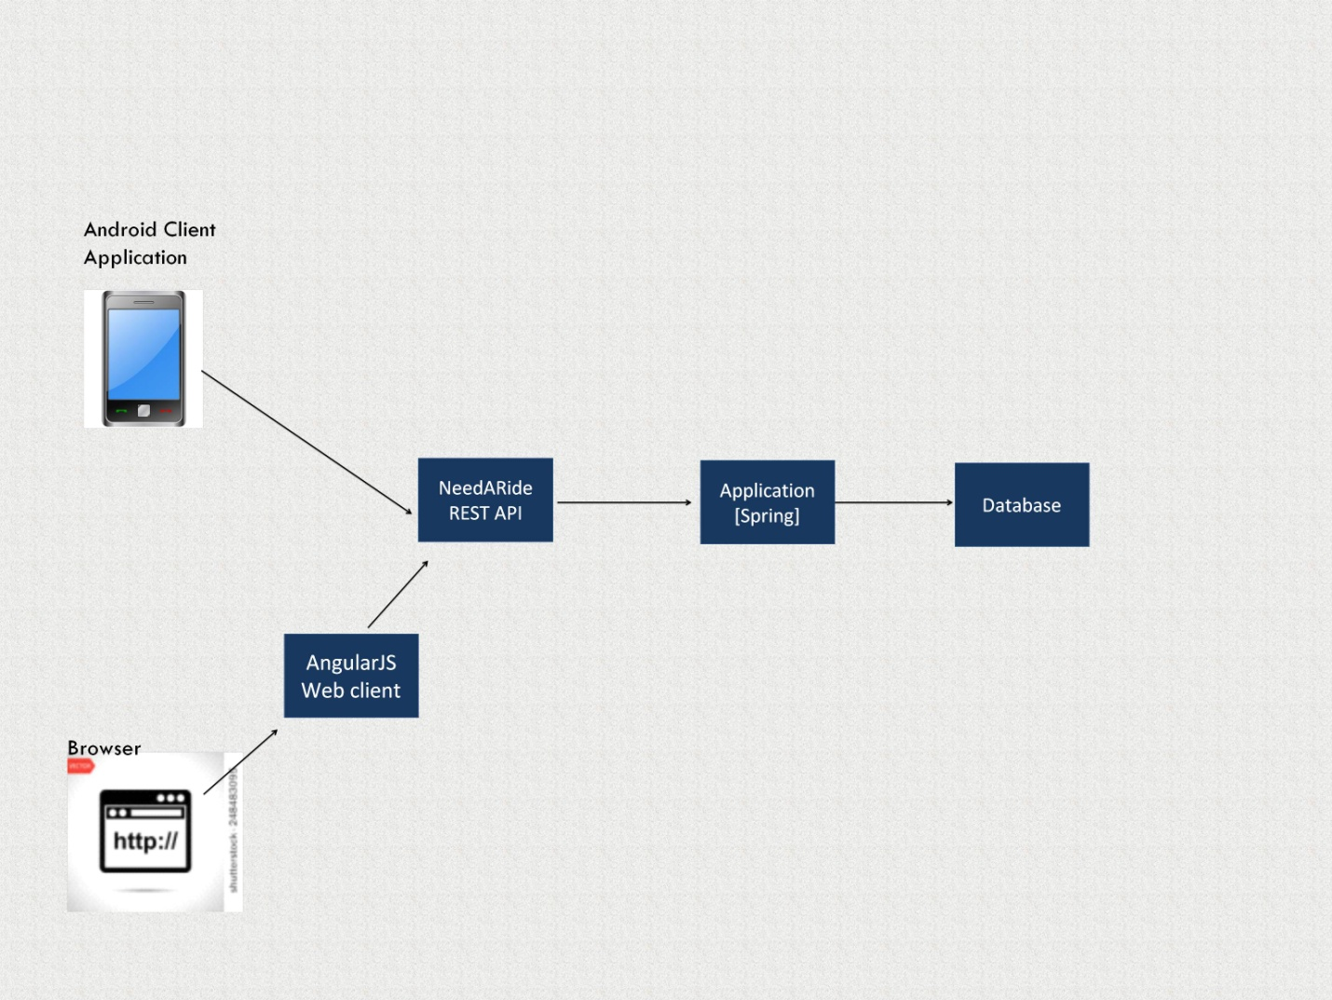

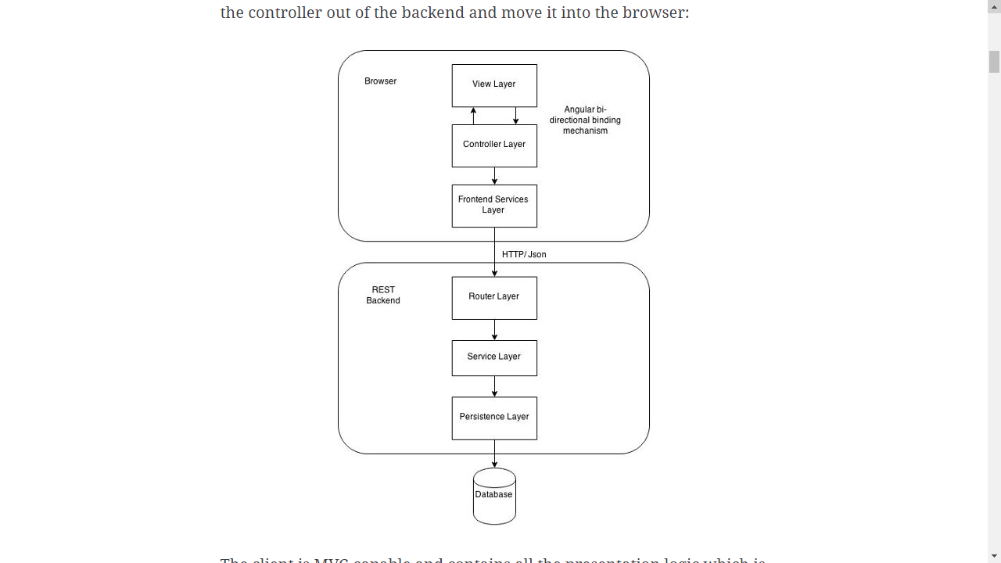

**Technical Details**

**NeedARide** uses Spring Framework. The application logic is exposed as a REST API and in addition to the we and android clients. The users can access the application two ways

* Through a native android application client, which enables the users to

access the portal on the go.

* Through a web browser, which talks to an Angular web client.
* Application uses MongoDB as database, geospatial indexing in Mongo database makes querying faster , making the application more efficient and highly scalable. Spring Data with MongoDB repository is used for database access.

The portal may be extended in future with a iPhone application client.

**Application Features**

* Search and register for available rides to your destination .
* Application has the ability to automatically pickup location of the user, from Google Map in Android application, if location services are enabled in web browser.
* If matching rides are not available, register for a ride, and the rider will be notified as soon as one becomes available.
* Offer a ride in app, and you will be notified when riders accept your ride.
* User can go to his profile to get details of his ride offers